1ES response to EVRT’s Q&A commentary.
Following EVRT’s published response to questions posed (in green here), 1st Effingham Scouts (1ES) have responded (in blue text here). The original document published 25th July by EVRT can be found on their website.

1. Is EVRT ignoring the history of the Scout HQ at King George V playing fields?
No, EVRT acknowledges the contribution made by 1ES in providing a valued activity for children. Once a fair licence is achieved, we hope to work in partnership with 1ES to support the activities the scouts provide.
EVRT’s response implies that the current occupation status is unfair, presumably for the community. 1ES disagrees with this in the strongest possible terms.
A) The building has been entirely operated (at great burden) to the Scouts since it’s construction. This could be considered political positioning by EVRT to whip up other users of the KGV who pay extremely onerous charges to EVRT for use of facilities operated by them. Although 1ES has not been paying a fee to EVRT, this does not make this a free ride as Paula Moss implies in her social media posts. Simply put, the Scouts (since construction) have invested significant sums of money to update the building -almost £20,000 in last 5 years – replacement windows, boiler, sound proofing being most recent, in addition to coping with the extremely high energy costs of recent years, plus funding every other operational overhead of a facility.
B) This current occupation arrangement with the Scouts has been very amicably in place since the building’s construction. Only within recent months has EVRT chair begun to label this an unfair arrangement. However, it is grossly unfair of EVRT to change the goal posts, provide misleading representations of the situation and put another charity serving the community to fund expensive legal defence against 3 separate threats of eviction, because it wishes to take over the building.
EVRT has ignored the history: the community engagement, the historic peaceful collaboration with EPC and KGV, the entire project management of the build undertaken by 1ES, with the subsequent management and maintenance costs since 1994. The build cost included substantial fundraising, involving the whole community of Effingham, along with the planning and sourcing of donations, plus interest free loans from friends & family in order to achieve the required result.
EVRT is rewriting history: all written correspondence since the dispute began, under EVRT Chair’s tenure, Paula Moss, has removed significant wording referring to Scouting in proposed contracts, yet the only signed document between EVRT & 1ES (signed by Liz Hogger in 2017 – and very amicably & collaborative agreed by both parties) is very clear that it is a a Scout HQ and that the Scouts raised the money, see Figure 1.
Note the distinctly different preamble of late from EVRT, see figure 2. A simple example of the rewriting of history.
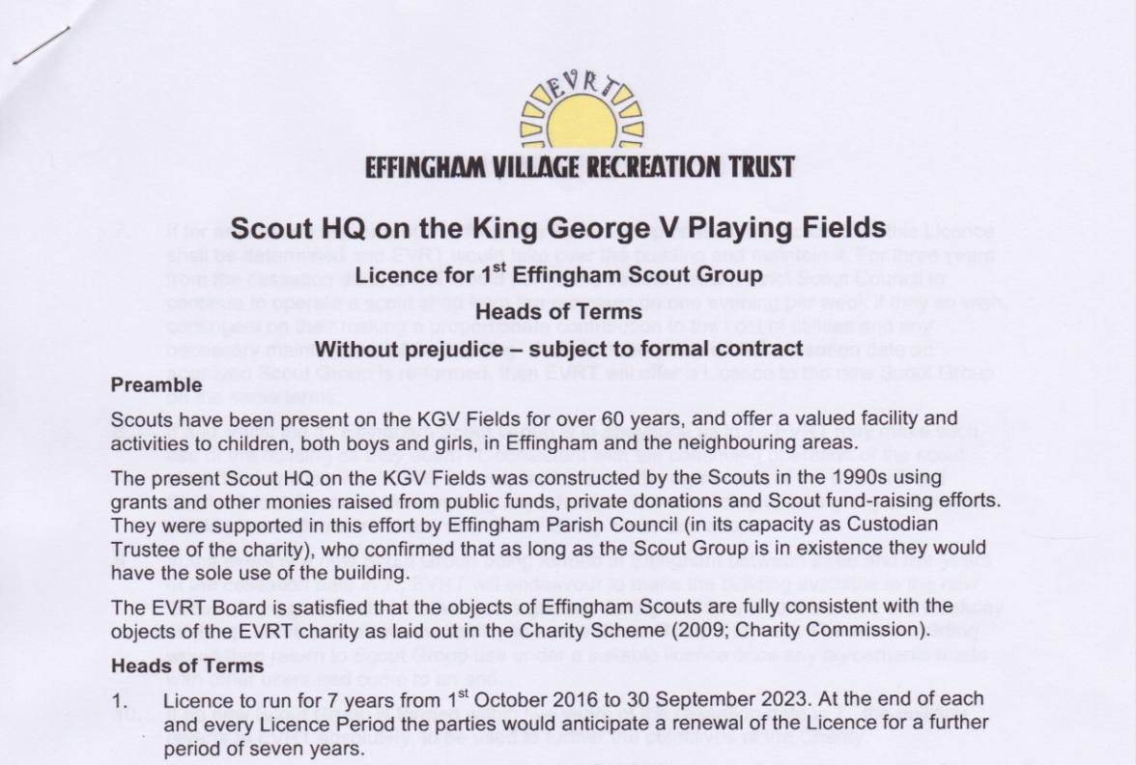
Figure 1 - Signed by Liz Hogger 2017
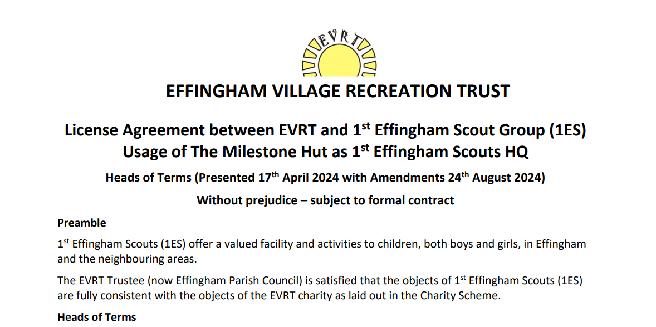
Figure 2 – example of EVRT's proposed – example of rewriting history.

Note also: the property specialist legal counsel, representing 1ES, formally laid out the key evidence to back up the Scouts version of history and defend the Scouts from the likely eviction that EVRT had set out. This document, known as Proprietary Estoppel, sets out the case and evidence to be presented if required in court. The lawyers were extremely thorough in their review of the documents presented by 1ES and EVRT to evidence the history and determine the occupancy status. However, EVRT/their legal representatives have never addressed a single point relating to this. A direct quote from the 1ES lawyers to EVRT’s legal representatives:
“We have set out clearly, in open correspondence, both the legal and factual reasons why our client has an irrevocable/perpetual licence for the use and occupation of the Premises (together with a right of access to it). By contrast, you have done no more than insist our client is a bare licensee. You are yet to put forward a credible argument in support of your client’s position and attempted challenge to a status quo that it (and/or EPC) has accepted without demur for over forty years. “

2. EVRT ignored the costs 1ES have spent on the building over the last 30 years in terms of the build, management, maintenance and improvements.
The building was constructed in 1996, funded largely by a grant from GBC at a total cost of £81,000. EPC as the Trustee paid for the building using this grant and a significant donation from the Scouts. This is a matter of public record.
The primary contributor was Guildford Borough Council who contributed 2/3 of the cost of £69,000 (ex.VAT). EVRT and other donations totalled £9000 and 1ES the remainder.
Let’s drill into the detail, as what EVRT have published is in most part inaccurate and incomplete.
a. The building was constructed in 1993/94 (not 1996)
b. The total cost eventually exceeded £85,000.
c. You state 1ES raised 1/3 of the £69,000 = £23,000, however the actual figure 1ES raised is nearer £40,000:
- Donations £9000 – of this £5000 was gratefully received from KGV Committee (EVRT wasn’t established until 2009) and the balance of £4000 in donations was from 1ES connections.
- Interest free loans: £7500, from family and friends of 1ES
- So, £23,000 + £4,000 + £7500 totals £34,500.
- Add to that the 1ES connections with Bookham & Horsley Rotary, which paid for the Toilets, and with longstanding Effingham Scout supporters Eddie & Pam Barnaville, who paid for the kitchen.

As Guildford Council’s contribution was £23,025 (matched by Surrey Council) this means that
1ES was the primary contributor - NOT GBC.
All the of the above can be evidenced and was recorded in publicly available Scouts accounts and AGM minutes. EVRT’s opposing view and statement that ‘this a matter of public record’, can be questioned as the evidence has been circumstantial not on public record, nor provided to the 1ES lawyer.
Under the planning conditions agreed as part of the permission for the new building, 1ES were to operate in the building as principal (but not exclusive) users under license from the KGV charity.

EVRT has chosen to misinterpret the entry on the planning application.
Bill Stringer, the Scout’s Architect, submitted the Planning application to Guildford Borough Council on behalf of 1ES.
Regarding section 6 (a) in the planning application - ‘Licence from Effingham Parish Council’ was not a new requirement – it was already in place. 1ES had been operating under special permission from KGV since 1978.
(The phrase ‘under licence’ is defined in Collins Dictionary as:
“If someone does something under licence, they do it by special permission from a government or other authority”)
Most significantly the planning application states in 3 sections that this is a replacement Scout Headquarters.
It is appropriate that they contributed to the running costs of the building since they were the principal users. The charity commission would not support an agreement that disadvantaged the home charity by giving disproportionately generous terms to any user group.
Correction: 1ES hasn’t just contributed, they have paid the full costs of running the new building for 31 years!
Regarding EVRT’s repeated comments regarding the Charity Commission guidance not allowing anything other than a bare licence of short term or as Paula puts it ‘disproportionately generous terms’, the 1ES lawyer does not accept EVRT’s interpretation. Nor have EVRT sought to confirm their understanding with the Charity Commission, which is what any other reasonable & cooperative charity would do. The 1ES lawyer has repeatedly requested this action to be taken by EVRT.
3. Why is there a clause in seven years that allows you to evict 1ES if it’s “no longer in the best interests of EVRT”?
There isn’t a clause within the current proposed license that allows EVRT to unilaterally evict 1ES on this basis. Previous versions included a clause that protected EVRT against misuse of the building. Charity Legislation requires that all agreements with 3rd party users must support the objects of the charity. Whilst 1ES operates as a scout group, using the hut for scouting activities only, it is acknowledged by EVRT within the proposed license that the aims of the organisation are consistent with the objects of the EVRT charity.
At this point in time, neither 1ES nor our lawyers have been sent a version that does not include this clause, so we are pleased to hear that EVRT intend to now remove this.
4. Why are you ignoring the agreement in 1978 between your predecessor and the Scout Group which gave the Scouts “de facto unrestricted use of the building”?
There was no agreement in 1978 to allow the scouts to have ‘defacto unrestricted use of this building’.
This building was completed in 1996. Prior to this, 1ES had shared use of a dilapidated wooden hut in the 1970s and 1980s. In 1978, 1ES was asked to pay the electricity bill for the facility. At the time they were the only group using the wooden hut which is why they were asked to pay the bill in full. Being the only user and being granted ‘defacto unrestricted’ use in perpetuity are entirely different things. As a charitable Trust governing recreation fields and village amenities, an exclusive agreement with any one group or individual would be illegal. At no point has the trustee offered any such representation to 1ES.
EVRT has repeatedly been made aware of the contents of the letter in 1978, which states that in return for the Scouts picking up the cost of the electricity bill, resulting in all costs of the hut being paid by the Scouts, the letter includes the following:
“As part of the review of the affairs of the KGV Management Committee it has become clear that it can no longer afford to pay the costs of the Scout hut. The 1st. Effingham Scout Group now has de facto unrestricted use of the hut as their Headquarters….”
Regarding the supposed illegality of having an agreement in some form that deviated from the bare licence offered by EVRT, the 1ES lawyers are not in agreement. Charity Commission guidelines are guidelines and, in their experience, have arranged many varied contracts on behalf of charities to settle their occupancy status.
5. Why do you deny the significant major contribution by the scouts to build the building in 1994?
EVRT does not deny that 1ES made a significant donation towards the cost of the building. The primary contributor was Guildford Borough Council who contributed 2/3 of the cost of £69,000 (ex. VAT). EVRT and other donations totalled £9,000 and 1ES donated the remainder. 1ES has benefitted from free use of the facility in recognition of its contribution.
Answered in detail in 2. above.
Moreover, 1ES was the sole contributor in terms of manpower and working effort. Without 1ES the building would not sit there today, continuing to be a valuable resource for the community.
6. Why in your latest offer, are you not allowing the Scouts the time they need in the building – why do you think they only operate in the time they are running a section?
The Scouts asked for an additional hour at each of their evening sessions. They currently operate for 6 hours per week, 30 weeks of the year. EVRT offered 15 hours mid-week and an additional full day at weekends during the 30 weeks. We also offered free use of our community meeting rooms for scout team and parent meetings. 1ES have not indicated any other requirement beyond those originally requested by 1ES in the course of discussions.
1ES have explained on numerous occasions that Scouting activities are not limited to the few hours each group meets each week. 15 hours per week is an arbitrary number created by EVRT which in no way reflects all that is needed to run a successful Scout Group.
The first we heard of the 30 weeks was when this number was quoted to us by the BBC as something we have apparently been offered.
It isn’t a full year and short of a school calendar year. The proposal so far is for pre-agreed slots in advance and experience to date has demonstrated a highly inflexible approach by EVRT to diary management, and a refusal for transparent diary sharing.
The extra events that are required during the year include District Meetings, AGM’s, Leadership Training, Leader meetings, Trustee Meetings, essential Fund Raising, Recruitment, Open Days, Safety Inspections, Kit Maintenance, Planning Meeting, Regular Ad Hoc Board Meetings.

Regarding EVRT’s likely future willingness to actually support the Scouts and to foster an environment for the successful operation of Scouts in the community, 1ES is sadly pessimistic. Experience to date (since dispute began) has been unnecessarily harsh and unreasonable. A recent example was a formal letter from EVRT’s legal representative threatening 1ES with prosecution for trespass in advance of our open day on March 29th 2025. This was a small event in the Scout HQ as an open invitation to our community to show the work we do and invite new members. This EVRT threat letter was entirely unreasonable and came out of the blue. There was no other communication or discussion from EVRT regarding this event.
7. Why are you and the Scouts having to each spend tens of thousands of pounds to challenge an arrangement that has been collaborative and peaceful for 50 years?
We are unaware of 1ES expenditure on legal costs. 1ES initiated the legal proceedings and have threatened court action on numerous occasions, with two different law firms including one global property specialist. The EVRT Trustee has an obligation to seek legal advice to protect trust interests and has done so in response to 1ES threats of imminent legal action. We have instructed a local law firm in Bookham to act on our behalf. As EVRT has made clear to 1ES on several occasions, our preference is to reach a solution through mediation. We offered this on March 28th and have yet to receive a response from 1ES. The suggestion that the arrangement has been collaborative and peaceful is disingenuous. EVRT and 1ES have been locked in negotiations for years.
Again, a lack of accuracy: we were threatened with eviction so took legal advice. We have been subject to repeated court threats, not the other way around. We continue to defend ourselves with the necessary support of legal experts, who have all confirmed the removal of the gate access was unlawful. There is a great level of confidence in our position, and we welcome mediation with an outcome which involves expert determination so we can bring this bitter and unnecessary battle to an end.
Taking the matter to court is unrealistic as it costs more than both charities can possibly afford so it is an unnecessarily aggressive and menacing ultimatum. Unfortunately, it would appear that greed has got the better of the new EVRT management team and tarnishes a long history of peaceful harmonious collaboration where the community came together and were not torn apart.
It is only in the last 2 years that the relationship has deteriorated – the Heads of Terms signed by both parties in 2017 is evidence of this previously amicable & cooperative relationship.
8. Are funds from resident’s council tax collected via the Effingham precept by Surrey County Council being used for EVRT legal fees?
No. EPC finances are entirely separate from EVRT. In the event of a legal action at court, EVRT will seek to reclaim costs on its own legal insurance. The Parish Council as Local Authority provides funding to EVRT to pay for the cost of providing the KGV facilities which are free for public use, the rest of the funding is paid by the various user groups including sports clubs, the pre-school, and other community clubs and activities.
EPC provide EVRT with £16,000 per quarter. This, we understand, is collected at source from Effingham resident’s council tax precept, then passed to EPC, then to EVRT. The other source of income as EVRT states is from other user groups. As a charity employed to represent community, funding for EVRTs legal fees will be in some way funded by them.
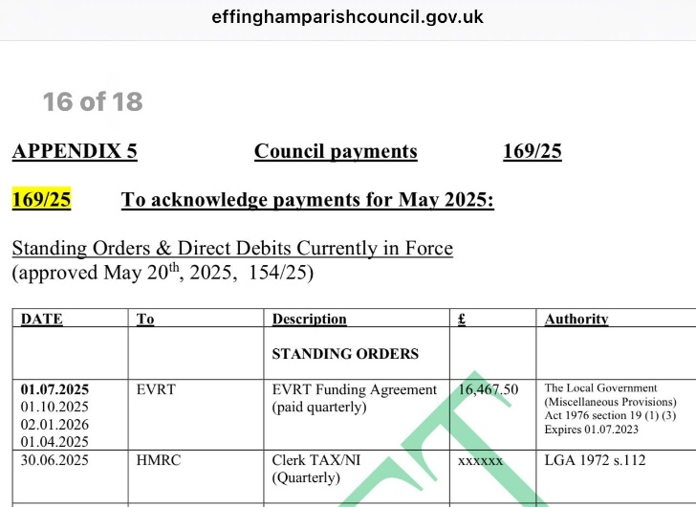
9. Why did you write to the 1ES 18 months ago and tell them that vehicular access to the Scout HQ would be fully restricted until a licence was signed by 1ES?
There is no vehicle access to the scout HQ. There is an emergency vehicle access track. All user groups seeking to use the emergency vehicle access gates at the Milestone Hut were asked to sign up to protocols governing use of the gates. 1ES has the option to sign the protocols and secure access for scout usage independent of a license agreement. The terms are not onerous and were enacted for the safety of visitors to the fields and security against incursion by unauthorised vehicles such as Traveller caravans. We only require that the gate is supervised during use. It is not dependent upon the licence but would form part of any licence agreement for any group seeking access via that gate. 1ES continues to have vehicular access to the main car park on Browns Lane used by all other groups at the KGV. The ‘pull in’ at the entrance to the Milestone Gate can also be used by 1ES and there is pedestrian access alongside that gate. If 1ES sign the gate protocol they will be given vehicular access.
Note that the EVRT Trustee wrote to 1ES some 18 months ago to explain the policy on gate security. There seems to be a misunderstanding that the letter was written by Effingham Parish Council (EPC).
This is not the case – there has always been vehicular access and parking outside the HQ.
EVRT know very well they are using the protocol to stop 1ES from being able to sign up to it, thus inhibiting return of access. Or more likely EVRT will use it as an excuse to terminate any occupational agreement as a breach.
Quite simply, their standard protocol is not suitable for Scout use.
EVRT have been told this on numerous occasions and even this week the lawyers have made this point yet again. The ratio of helpers to Scouts/Cubs/Beavers/Squirrels means that they cannot have someone manning the gate at all times and due to the nature of the way the shop operates the gate needs to be open during shop opening hours.
A variation of the protocol needs to be offered that is a realistic, workable alternative.

1ES Legal counsel repeatedly has made it clear restricting vehicle access is illegal. Not to mention a safety issue for young children accessing our community service. EVRT has offered conflicting and confusing arguments about removal of access, here are the words of the 1ES lawyer calling this out:
“If your client is willing to accept that (i) a right to access the Premises with or without vehicles was granted in common with our client’s licence; and (ii) will subsist as long as the licence does, then we need say no more about the point. If, however, it claims that our client was not granted a right of vehicular access, then it follows that such a right will have accrued by virtue of our client having accessed the Premises with vehicles without permission for a period in excess of 20 years (which it will be able to prove without any difficulty if so required). In either case, the end result is the same: your client and/or EPC has unlawfully obstructed our client’s right of access to the Premises, because the purported right of termination does not exist.”

10. Why are you undermining the invaluable community work Barnes Wallis accomplished in Effingham to support local families and children? As the president of 1E Scouts, he held this cause in the highest regard, considering it a vital part of his legacy.
EVRT refutes this suggestion. Sir Barnes Wallis was a founding father of the KGV and an enthusiastic supporter of its mission. He was one of the Purchasing Trustees who acquired the land for the KGV in 1938, and subsequently he was the Chair of the Parish Council when the charity was first created in 1951 with the object of providing recreational facilities for all Effingham residents. Far from undermining his legacy, EVRT aims to increase free participation and enjoyment of trust facilities by residents across the site, as Barnes Wallis intended. In denying access to the Milestone Hut for other community groups, 1ES would be guilty of exclusion as they seek exclusive rights to a community building and wish to profit commercially by hiring out the Hut to non-scout users.
The Heads of Terms, signed in 2017 by both 1ES and EVRT (the current EPC Chair and EVRT Vice Chair Liz Hogger being one of the EVRT signatories) included a clause allowing EVRT to hire out the building to other users, following agreement with the Scout Group. This has remained in place ever since but surprisingly has never been used by EVRT.
The Scout HQ has always been available for use by the community since 1994.
The accusation of 1ES profiteering commercially is outlandish.1ES accounts are open to the public domain – it is a charity which does not make a profit, and in common with many charities, has to fundraise, simply to get by.

